 | 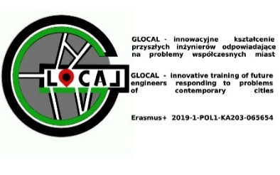

AGENDA OF THE PRACTICAL SCIENTIFIC CONFERENCE (E6), Klaipeda 27.04.2022, “DEVELOPMENT OF SUSTAINABLE ENVIRONMET”
Klaipeda State University of Applied Sciences (KVK) , Bijūnų str. 10, 234 aud. Klaipeda, Lithuania
ONLINE LINK: https://teams.microsoft.com/l/meetup-join/19%3ameeting_MzYzMDMwY2YtZmE1Ni00ZDhiLWIwOWMtZWJhNWVkZTE0MzE3%40thread.v2/0?context=%7b%22Tid%22%3a%22930cc46e-c48b-4b2e-8bd3-1fd489b1851c%22%2c%22Oid%22%3a%22f67a54ec-84d1-4820-a33c-78fb30a12623%22%7d
Wednesday, April 27, 2022
Time | Agenda item description
12:00-13:00 | Welcome coffee
13:00-14:00 | Marija Buivydienė (Lithuania)  KLAIPĖDA CITY’S PUBLIC SPACES: CURRENT SITUATION AND PERSPECTIVES
14:00-14:30 | Robert Grygo (Poland)  SPECIAL REINFORCED CONCRETE STRUCTURES. INNOVATIONS IN RESEARCH
14:30-15:00 | Salih Seckin (Turkey)  INTERNATIONAL COOPERATION: SCIENTIFIC CURRENT ISSUES AND PERSPECTIVES
15:00-15:30 | Jose Carlos Almeida (Portugal)  COOPERATION AND DEVELOPMENT OF RESEARCH PROJECTS
15:30-16:00 | Dorota Gawryluk (Poland)  INTELECTUAL OUTPUT IN GLOCAL: EXPERIENCE, DISSEMINATION, COOPERATION  Discussion
16:00-17:00 | Edita Abalikštienė, Giedrė Ivavičiūtė (Lithuania)  LITHUANIAN LANDSCAPE STRUCTURE AND OPTIMALITY
17:00-18:00 | Visiting Japan garden. Discussion (Kretinga district)
19:00-20:00 | Dinner
Location (legend): | Klaipeda State University of Applied Sciences (KVK) , Bijūnų str. 10, Klaipeda, Lithuania, GIS Competence Center (234 aud.)  ONLINE LINK: https://teams.microsoft.com/l/meetup-join/19%3ameeting_MzYzMDMwY2YtZmE1Ni00ZDhiLWIwOWMtZWJhNWVkZTE0MzE3%40thread.v2/0?context=%7b%22Tid%22%3a%22930cc46e-c48b-4b2e-8bd3-1fd489b1851c%22%2c%22Oid%22%3a%22f67a54ec-84d1-4820-a33c-78fb30a12623%22%7d
Selected preliminary agenda points can be moved from day to day. Detailed information about aims of the meetings, content of workshops and location of all activities will be delivered to participants during opening.

