 |  |  | 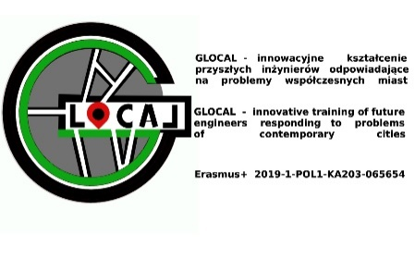
AGENDA OF THE Glocal coordinators meeting, Klaipeda
(2nd transnational project meeting)
27-28-29.04.2022
Klaipeda State University of Applied Sciences (KVK) , Bijūnų str. 10, 232 room, Klaipeda, Lithuania
ONLINE LINK: https://teams.microsoft.com/_#/pre-join-calling/19:0d983b29ed47470d9805e83e6de5944d@thread.tacv2
Wednesday, April 27, 2021
Time | Agenda item description
12:00-13:00 | Welcome coffee
13:00-15:00 | Project activities overview
15:00-18:00 | GLOCAL project coordinators meeting - working group.  (Evaluation of intellectual outputs dissemination)
Thursday, April 28, 2022
Time | Agenda item description
11:00-13:00 | GLOCAL project coordinators meeting - working group (discussion about 1st summer school in Bialystok -evaluation and conclusions. Remote and blended part of 1st summer school agenda)
14:00-16:00 | GLOCAL project coordinators meeting - working group. (preparation of the 2nd summer school agenda)
 | Free time
 | Friday, April 29, 2022
10:00-14:00 | GLOCAL project coordinators meeting - working group (preparation of the 3rd summer school agenda). Conclusions of the Meeting
Location (legend): | Klaipeda State University of Applied Sciences (KVK) , Bijūnų str. 10, Klaipeda, Lithuania, GIS Competence Center (232 room)  ONLINE LINK: https://teams.microsoft.com/_#/pre-join-calling/19:0d983b29ed47470d9805e83e6de5944d@thread.tacv2
Selected preliminary agenda points can be moved from day to day. Detailed information about aims of the meetings, content of workshops and location of all activities will be delivered to participants during opening.

